BIOGRAPHY 

***U N I T E D S T A T E S A I R F O R C E***

SENIOR MASTER SerGeanT (ret) LEON L. MARTIN III

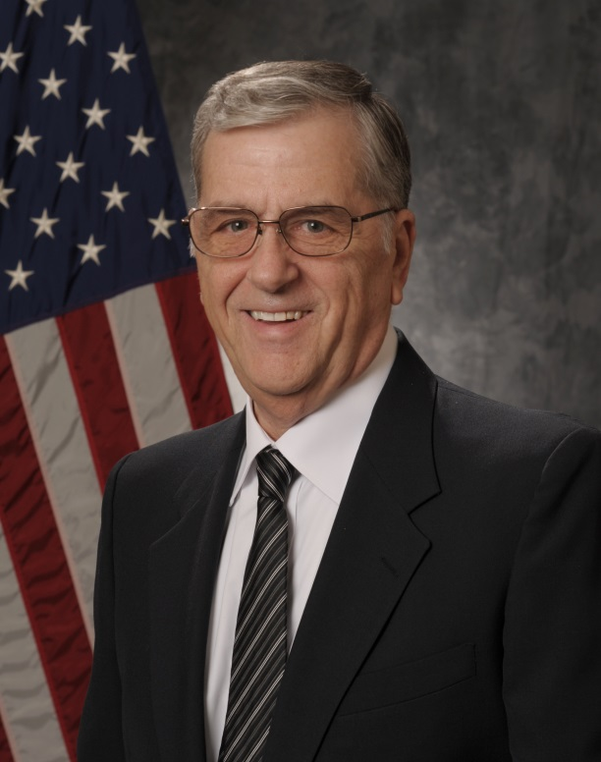Senior Master Sergeant (Ret) Leon (Lee) L. Martin III, at retirement was the Mission Management Superintendent of the 6920 Electronic Security Squadron at Misawa Air Base, Japan. He is currently the the Webmaster and Newsletter Publisher, Retiree Activities Office, 35th Fighter Wing, Misawa Air Base, Japan. He is responsible for creating, maintaining and publishing the organization’s internet web pages and the quarterly newsletter as well as providing assistance and information to approximately four hundred and fifty retirees, dependents and survivors of military retirees in northern Japan (to include the prefectures of Fukushima, Yamagata, Miyagi, Iwate, Akita, Aomori and the northern island of Hokkaido). He assists in casualty affairs, social security issues, tax preparation, a ensuring survivors of military personnel from all branches of service receive the benefits they are entitled to. He is a life member of the Air Force Association and the Air Force Sergeants Association as well as a member of the Misawa Military Retirees Association.

SMSgt Martin was born on 12 November 1949 in Passaic, New Jersey and grew up in neighboring Clifton. He graduated from Pope Pius XII High School in Passaic, in June 1967 and entered the Air Force in July 1968. Upon completion of basic training at Lackland Air Force Base, Texas, he went to Keesler Air Force Base, Mississippi, for training as a Morse Intercept Operator.

His next assignment was to the 6931st Security Squadron on Iraklion Air Station, Crete, Greece, in March 1969. Upon completion of this 18-month tour, he was reassigned to the 6921st Security Group at Misawa Air Base, Japan. After three years at Misawa, he PCS’d to the 6922 Security Squadron at Clark Air Base, Republic of the Philippines where he spent 2 years. In September of 1975, he was reassigned to the 6948th Security Squadron (Mobile), Kelly AFB, Texas with operations located at Medina Training Annex in San Antonio Texas. After two and a half years, he attended survival schools required for flying status personnel and moved to the 6990th Electronic Security Squadron, Kadena Air Base, Okinawa, Japan as an Airborne Morse Systems Supervisor. He spent four years on flying status, lo9ffing 179 flights and over 1700 flying hours. In September of 1982 he returned to Misawa Air Base with the 6920th Electronic Security Group. In the early 1980s the Major Command was renamed from USAF Security Service to Electronic Security Command, hence the new unit designation. SMSgt Martin retired from active duty in July of 1992 and remained in place at Misawa.

After retirement, SMSgt Martin served as a computer technician with the 432nd Services Squadron for two years,Computer Technician with the newly contracted Aerial Port for two and a half years, computer technician with the DRMO office at Misawa for two more years and finally as the Information Assurance Officer with 35th Civil Engineer Squadron for 14 years. He retired in August, 2013.

SMSgt Martin resides in Oirase Chou, Aomori Prefecture, Japan with his spouse Miki and step-son, Yuuki of Towada City, Japan.

**EDUCATION**

1969 Air Force Noncommissioned Officer Preparatory Course

1979USAF Security Service NCO Leadership School

1983 USAF Security Service Noncommissioned Officer Academy

1985 USAF Senior Noncommissioned Officer Academy (correspondence)

1986 Associate’s Degree, Communications Technology, Community College of the Air Force

1988 1-year Certificate in Japanese Studies

1991 Bachelor of Arts, Management Studies

**ASSIGNMENTS**

1. February 1969 – September 1970, Morse Intercept Operator, 6931st Security Squadron, Iraklion Air Station, Crete, Greece.

2. September 1970 – September 1973, Morse Intercept Operator High Frequency Direction Finding Operator, 6921st Security Group, Misawa Air Base, Japan.

3. September 1973 – September 1975, Morse Systems Operator/High Frequency Direction Finding Operator, 6922nd Security Squadron, Clark Air Base, Republic of the Philippines.

4. September 1975 – June 1978, Morse Systems Supervisor, 6948th Security Squadron (Mobile), Kelly Air Force Base, San Antonio, Texas.

5. September 1978 – September 1982, Airborne Morse Systems Supervisor, 6990th Electronic Security Squadron, Kadena Air Base, Okinawa, Japan.

6. September 1982 – July 1992 – Various titles, culminating as Mission Management Superintendent / Far East High Frequency Direction Finding Network Superintendent, 6920th Electronic Security Group, Misawa Air Base, Japan.

7. 1 July 1992, retired from Active Duty remaining in place at Misawa, Japan.

8. July 1992 – November 1994, Computer Technician, 432nd Services Squadron, Misawa Air Base, Japan

9. November 1994 – June 1996, Computer Technician, AMC Contracted Aerial Port Operation, Misawa Air Base, Japan.

10. June 1996 – June 1999, Computer Technician, Defense Reutilization and Marketing Office, Misawa Air Base, Japan.

11. June 1999 – August 2013, Information Assurance Officer / Webmaster, 35th Civil Engineer Squadron, Misawa Air Base, Japan

12. August 2013 – Retired.

13. September 2014 – present, Webmaster / Newsletter Publisher, Retiree Activities Office, 35th Fighter Wing, Misawa Air Base, Japan

**MAJOR AWARDS AND DECORATIONS**

Meritorious Service Medal with 1 oak leaf cluster

Air Medal with six oak leaf clusters

Air Force Commendation Medal with 1 oak leaf cluster

Air Force Achievement Medal

Air Force Outstanding Unit Award with 3 oak leaf clusters

Air Force Combat Crew Medal

Good Conduct Medal with six oak leaf clusters

Small Arms Marksmanship award with 1 oak leaf cluster

(Current as of June 2015)