BIOGRAPHY 

***U N I T E D S T A T E S A I R F O R C E***

cHIEF MASTER SerGeanT (ret) DAVID J. BARTON

Chief Master Sergeant (Ret) David (Dave) J. Barton at retirement was

the Maintenance Superintendent of the 35th Maintenance Squadron at Misawa Air Base, Japan. He is currently the Deputy Director, Retiree Activities Office, 35th Fighter Wing, Misawa Air Base, Japan. He is responsible for providing assistance and information to approximately four hundred and fifty retirees, dependents and survivors of military retirees in northern Japan (to include the prefectures of Fukushima, Yamagata, Miyagi, Iwate, Akita, Aomori and the northern island of Hokkaido). He is responsible for assisting in casualty affairs, social security, tax preparation, and ensuring survivors of military personnel from all branches of service receive the benefits they are entitled to. He is a life member of the Air Force Association, Air Force Sergeants Association, Veterans of Foreign Wars, Misawa Chiefs Group, Misawa Military Retirees Association, and Thailand, Laos, Cambodia Brotherhood.

Chief Barton was born 30 June 1947 in Philadelphia, Pennsylvania. He graduated from Neshaminy Senior High School, Langhorne. Pennsylvania, in June 1965 and entered the Air Force that same month. Upon completion of basic training at Lackland Air Force Base, Texas, he was assigned to the 3380th Civil Engineering Squadron at Keesler Air Force Base, Mississippi, for training as a Protective Coating Specialist.

His next assignment was to Misawa Air Base, Japan, in June 1967. While at Misawa he retrained into the Corrosion Control career field. Upon completion of this 3-year tour, he was reassigned to Barksdale Air Force Base, Louisiana, to the 2nd Field Maintenance Squadron. He left Barksdale in August 1971 for an assignment with the 40th Aerospace Rescue and Recovery Squadron at Nakhon Phanom Royal Thai Air Base, Thailand. From NKP, he went to K. I. Sawyer Air Force Base, Michigan, in September 1972, where he was in charge of the Corrosion Phase Dock on B-52 and KC-135 aircraft. Three years later, he returned to Thailand for duty at Udorn Royal Thai Air Base. When Udorn was closed in December 1975, he finished the last 6 months of his short tour obligation at Clark Air Base, Republic of the Philippines. He was then assigned to Kadena Air Base, Okinawa, for 3 years in May 1976. Upon completion of this consecutive overseas tour, he transferred to Eglin Air Force Base, Florida, and was assigned to the 55th Aerospace Rescue and Recovery Squadron. Chief Barton was selected in May 1981 for duty at Headquarters Military Airlift Command, Scott Air Force Base, and Illinois. While at Scott, his duties included the Command Corrosion Control Manager and Chief, Field Maintenance Branch, Director of Maintenance Engineering, Deputy Chief of Staff Logistics. He was reassigned in September 1987 to Misawa Air Base, Japan where he crossed-flowed into the Aircraft Systems Chief enlisted career field. In addition to his stateside and overseas assignments, Chief Barton has deployed in support of humanitarian operations in Central America and Southeast Asia. Chief Barton, originally from Levittown, Pennsylvania, resides in Rokunohe, Japan with his spouse Chiyo Kudo of Misawa City, Japan.

**EDUCATION**

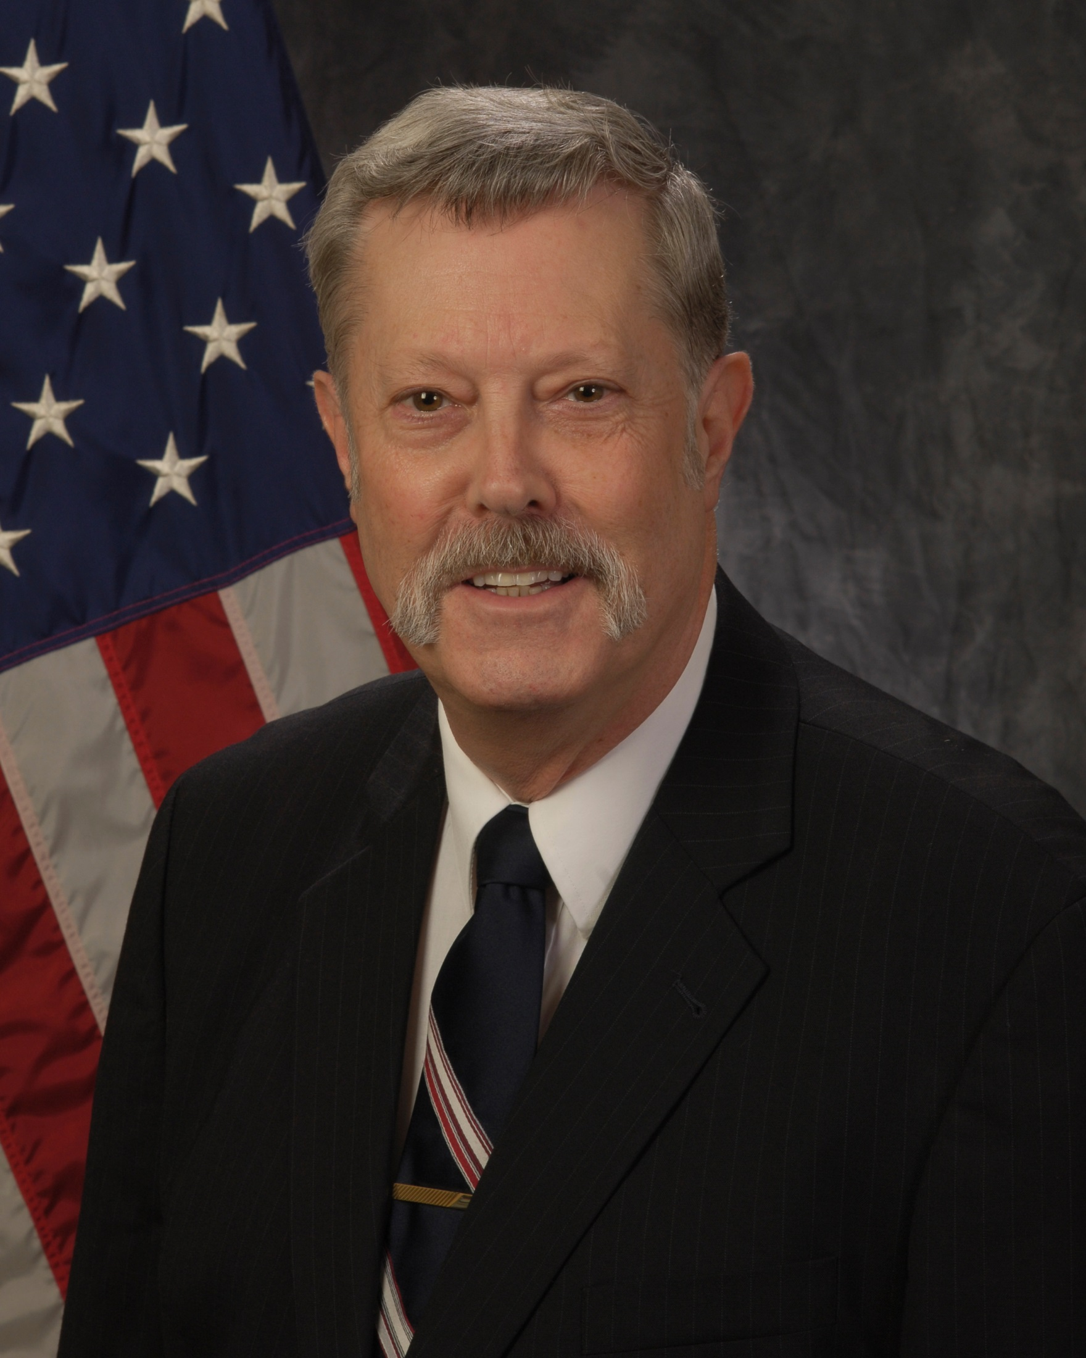

1969 Air Force Noncommissioned Officer Preparatory Course

1979Aerospace Defense Command Noncommissioned Officer Academy

1983 USAF Senior Noncommissioned Officer Academy

1992 Associate’s Degree, Metals Technology, Community College of the Air Force

**ASSIGNMENTS**

1. August 1965 - June 1967, Protective Coating Specialist, 3380th Civil Engineering Squadron, Keesler Air Force Base, MS.

2. June 1967 - June 1970, Aircraft Corrosion Control Specialist, 475th Field Maintenance Squadron, Misawa Air Base, Japan

3. June 1970 - August 1971, Aircraft Corrosion Control Supervisor, 2nd Field Maintenance Squadron, Barksdale Air Force Base, LA.

4. August 1971 - August 1972, NCOIC Corrosion Control, 40th Aerospace Rescue and Recovery Squadron, Nakhon Phanom Royal Thai Air Base, Thailand

5. August 1972 - August 1975, NCOIC Corrosion Phase Dock, 410th Field Maintenance Squadron, K.I. Sawyer Air Force Base, MI.

6. August 1975 - December 1975, Corrosion Control Supervisor, 432th Field Maintenance Squadron, Udorn Royal Thai Air Base, Thailand

7. December 1975 - June 1976, Corrosion Control Supervisor, 3rd Field Maintenance Squadron, Clark Air Base, Republic of the Philippines

8. June 1976 - September 1979, Corrosion Control Supervisor, 18th Field Maintenance Squadron, Kadena Air Base, Okinawa

9. September 1979 – September 1981, Field Maintenance Branch Chief, 55th Aerospace Rescue and Recovery Squadron, Eglin Air Force Base, FL.

10. September 1981 - September 1987, Command Corrosion Control Manager, Headquarters Military Airlift Command, Scott Air Force Base, IL.

11. September 1987 – March 1996, Maintenance Superintendent, 35th Maintenance Squadron, Misawa Air Base, Japan

12. March 1996 – August 2005, School Bus Operations Supervisor, 35th Logistics Readiness Squadron, Misawa Air Base, Japan

13. August 2005 – present, Deputy Director, Retiree Activities Office, 35th Fighter Wing, Misawa Air Base, Japan

**MAJOR AWARDS AND DECORATIONS**

Meritorious Service Medal with three bronze oak leaf clusters

Air Force Commendation Medal

Air Force Achievement Medal

Presidential Unit Citation with Valor device

Air Force Outstanding Unit Award

Air Force Organizational Excellence Award

Korean Defense Service Medal

Armed Forces Expeditionary Medal

Vietnam Service Medal

Humanitarian Service Medal

Republic of Vietnam Gallantry Cross with Palm Unit Citation

Republic of Vietnam Campaign Medal

(Current as of June 2015)