**BIOGRAPHY**

***U N I T E D S T A T E S A I R F O R C E***

**MASTER SERGEANT (RET) WILLIAM H. TUTTLE**

Master Sergeant (Ret) William (Bill) Tuttle is a volunteer staff member at the Retiree Activities Office, 35th Fighter Wing, Misawa Air Base, Japan. He is responsible for providing assistance to nearly four hundred and fifty retirees, dependents, and their survivors in the six prefectures of Tohoku (northeast Japan) and the northern island of Hokkaido. Areas of assistance include retirement benefits and entitlements, casualty affairs, social security and survivor benefits and tax preparation. His formal education in Japanese Language is beneficial in assisting the many Japanese surviving widows within the Misawa RAO jurisdiction.

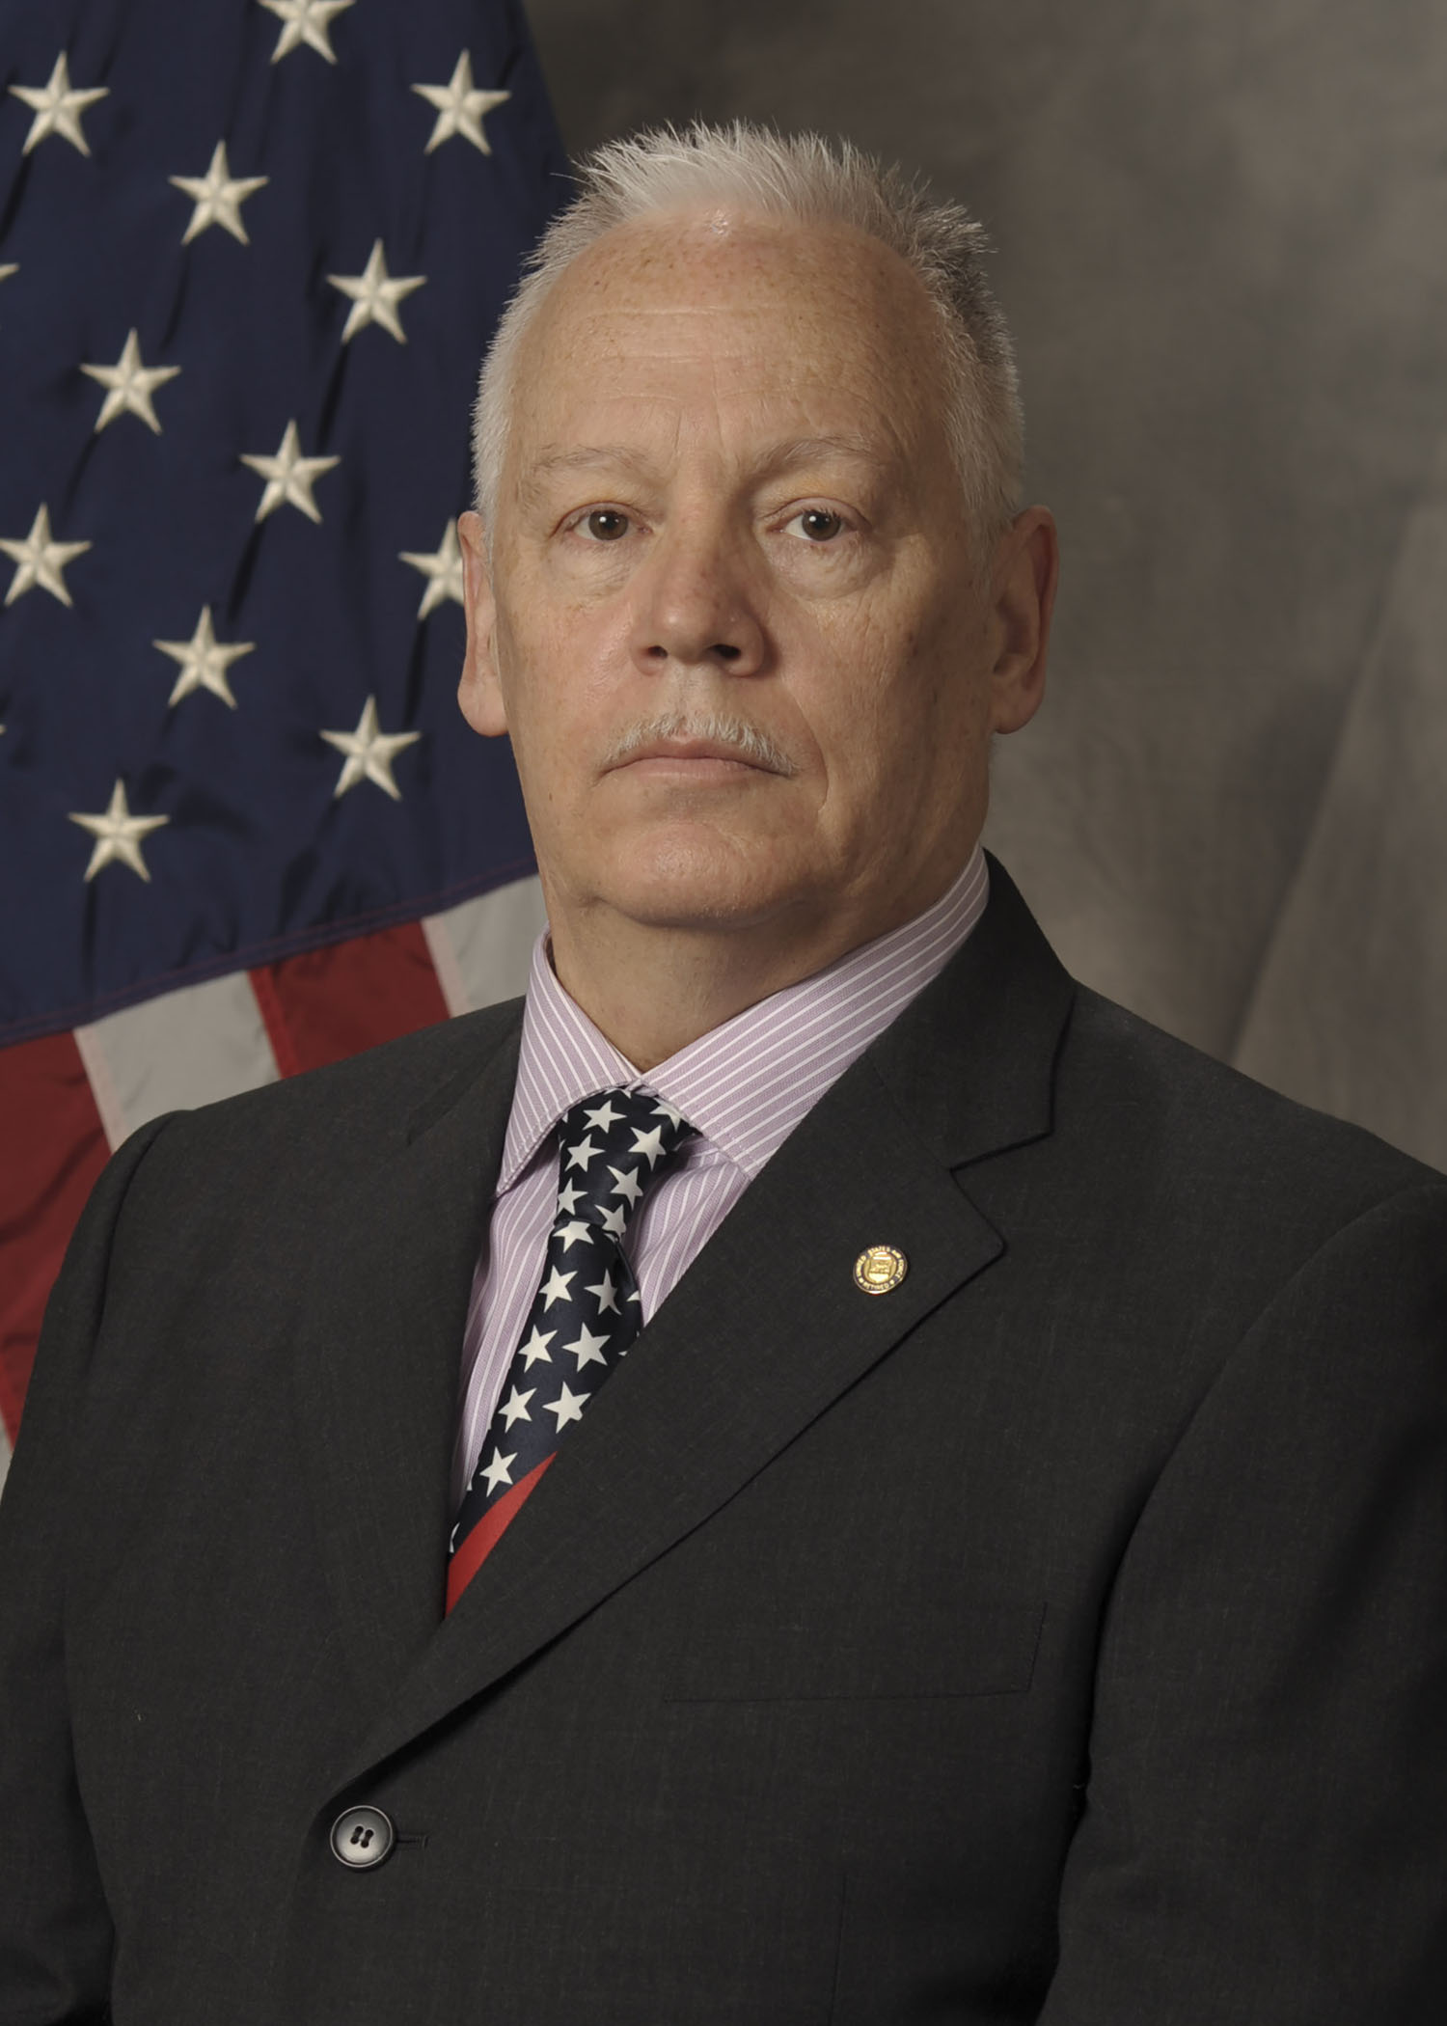

**Position:**

**2.5” from Top**

**.5” from Right Edge**

MSgt Tuttle was born in Waltham, Massachusetts in 1961, and in 1965 moved with his family to Cape Cod, where he spent his entire youth. One year after graduating in 1979 from Bourne High School, MSgt Tuttle enlisted in the Air Force as an Automatic Flight Control Systems Technician (32530). MSgt Tuttle spent half of his 24-year Air Force career maintaining various avionic systems on C-130, B-52, KC-135, and RC-135 (SEI) aircraft. As a young Buck Sergeant, Sgt Tuttle was selected for a special duty assignment with Air Force Recruiting Service, and spent five years as a non-prior enlisted recruiter in West Warwick, Rhode Island. Following his tour in USAF Recruiting, then SSgt Tuttle returned to avionics maintenance for another seven years, five of which were at a special duty assignment with the 82nd Reconnaissance Squadron at Kadena AB, Okinawa. Eager to take on new challenges, TSgt Tuttle cross trained into another special duty assignment as a Professional Military Education instructor at the 35th Fighter Wing Airman Leadership School at Misawa Air Base. Here, he was responsible for preparing front-line supervisors for the Air Force, Army, Navy and Japan Air Self Defense Force. Upon promotion to the rank of MSgt, Tuttle was selected to replace the outgoing ALS Commandant. MSgt Tuttle served his final four years as the Commandant of Misawa’s Airman Leadership School. After retirement from the Air Force in November 2004, MSgt Tuttle worked for Harley-Davidson Military Sales Far East Division until his retirement in 2016. Tuttle currently resides in Misawa City, Japan with his spouse Asako, daughters Sakura Liberty and Emily Kokoro, and son Barry Hikaru. He became a volunteer for the Retiree Activities Office in January 2021.

**EDUCATION**

1979 Diploma - Bourne High School, Cape Cod, Massachusetts

1996 Associate of Arts, Avionics Systems Technology, Community College of the Air Force

1999 Associate of Arts, Instructor of Technology, Community College of the Air Force

2018 Associate of Arts, General Studies, University of Maryland University Campus

2019 Bachelor of Arts, East Asian Studies/History, University of Maryland University College

**ASSIGNMENTS**

1. Aug 1980 - Feb 1981, 3362nd School Squadron, Chanute AFB, Illinois.

2. Feb 1981 ~ Dec 1982, 314th Avionic Maintenance Squadron, Little Rock Air Force Base, Arkansas.

3. Dec 1982 ~ Jun 1984, 376th Avionic Maintenance Squadron, Kadena Air Base, Okinawa, Japan.

4. June 1984 ~ Jun 1985, 93rd Avionic Maintenance Squadron, Castle Air Force Base, California.

5. Jun 1985 ~ Sep 1988, 3512th USAF Recruiting Squadron, Westover Air Force Base, Massachusetts.

6. Sep 1988 ~ Jul 1990, 3519th USAF Recruiting Squadron, Pease Air Force Base, New Hampshire.

7. Aug 1990 ~ Sep 1992, 350th Air Refueling Squadron, Beale Air Force Base, California.

8. Sep 1992 ~ Jul 1997, 82nd Reconnaissance Squadron, Kadena Air Base, Okinawa, Japan.

9. Jul 1997 ~ Nov 2004, 35th Fighter Wing Airman Leadership School, Misawa Air Base, Japan.

Jan 2005 ~ Feb 2016, Harley-Davidson Military Sales Far East Division, Misawa Air Base, Japan

**AWARDS AND DECORATIONS**

Airman’s Medal

Meritorious Service Medal

Air Force Commendation Medal

Air Force Achievement Medal

Air Force Outstanding Unit Award w/5 Oak Leaf Clusters

Air Force Good Conduct Medal w/7 Oak Leaf Clusters

National Defense Service Medal w/1 Bronze Service Star

Korean Defense Service Medal

Air Force Overseas Long Tour w/3 Oak Leaf Clusters

Air Force Longevity Service Award w/5 Oak Leaf Clusters

Air Force Recruiter Ribbon

USAF NCO Professional Military Education Ribbon w/1 Oak Leaf Cluster

Small Arms Expert Marksmanship ribbon/Rifle

Air Force Training Ribbon

(Current as of May 2022)